Interpreting ClientTrack Codes

# Introduction

Due to the way ClientTrack stores information, values are often saved in the database as alphanumeric codes rather than the text displayed on the user’s end. In this example, the exit destination values are displayed as numbers rather than the full exit destination description.

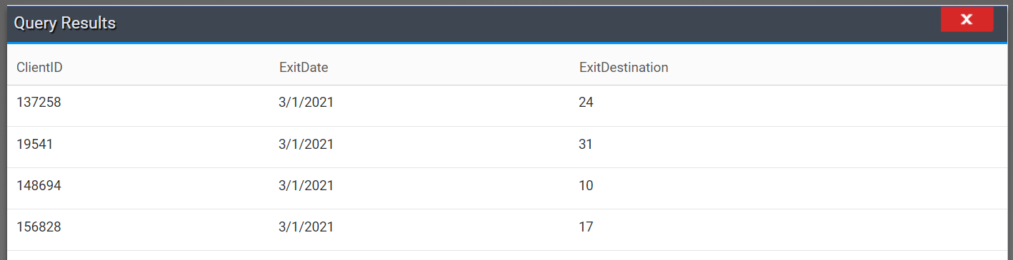

To display these values as text in a query, the query writer can:

1. Use a CASE statement to translate the code into the display text
2. Use a subquery to get the text value automatically
3. Join to the cmComboBoxItem table

The following table can be used to identify the appropriate solution for individual use cases.

|  |  |  |  |
| --- | --- | --- | --- |
|  | Relatively easy | Resistant to human error | Can be used in aggregation |
| **CASE statements** | **X** |  | **X** |
| **Automatic subquery** | **X** | **X** |  |
| **Formal join** |  | **X** | **X** |

# CASE Statements

To use a case statement, simply paste the following code block into an editor and replace everything in brackets with the appropriate text.

CASE

WHEN [table].[column] = '[value_1]’ THEN '[desired_value_1]'

WHEN [table].[column] = '[value_2]’ THEN '[desired_value_2]'

…

WHEN [table].[column] = '[value_n]’ THEN '[desired_value_n]'

END

When the code is ready, add a new column to the query with the following steps.

1. Right click in the query area and click “Add SQL Expression”  
   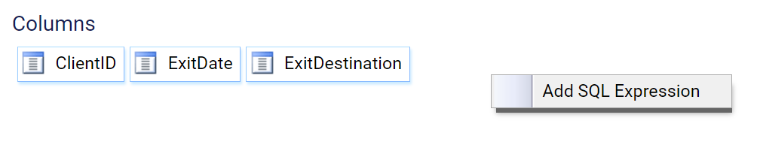
2. Enter the column name and paste in the expression from above.   
   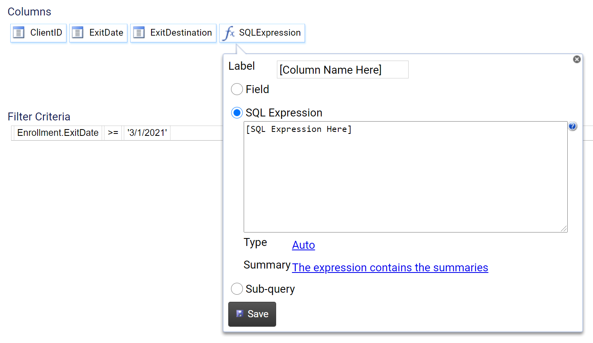
3. The summary type can be either “The expression contains the summaries” or “None. If there’s an aggregate, this field will group.”

# Automatic Subqueries

Automatic subqueries are the simplest way to get the value of ClientTrack codes.

1. Right click on the column title and select “Get Description”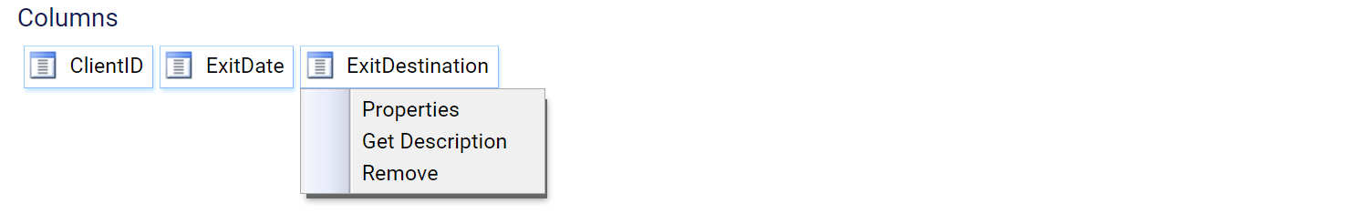
2. If multiple options are given for matching tables, select the one that aligns with the form/s where users most often enter the information you are trying to link to.
3. The system will allow you to select “None. If there’s an aggregate, this field will group” as the summary type, but it will not actually allow you to group this variable.

# Join to cmComboBoxItem

Using a formal join to get the values for the codes is the most time-consuming method, but it is the most technically correct and flexible one.

1. Look up the values you need to match on in the cmComboBox Reference document saved on the CHIP GitHub ([link to download](https://github.com/chipindy/CHIP_HMIS/raw/main/NumberItemCrosswalk.xlsx)). The text values you want are in column F, the codes you’re matching to are in column E, and the values you’ll need to find for the join are in columns A and B. In our exit destination example, we look for the exit destination values in column F until we find that the column A and B values we need are Destination and HMIS2020, respectively.  
   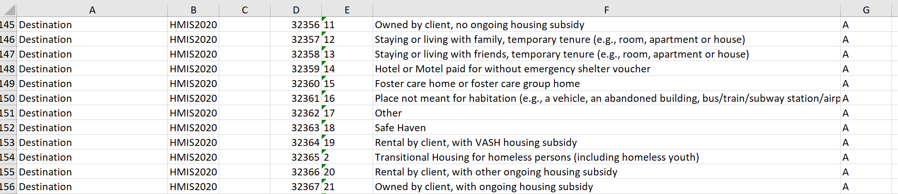
2. Click “Edit Data Definition” in the upper left-hand corner of the Query Designer editor.  
   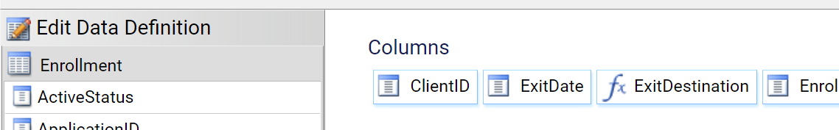
3. Click the table with a green plus sign in the top left of the data definition window to add a new table.  
   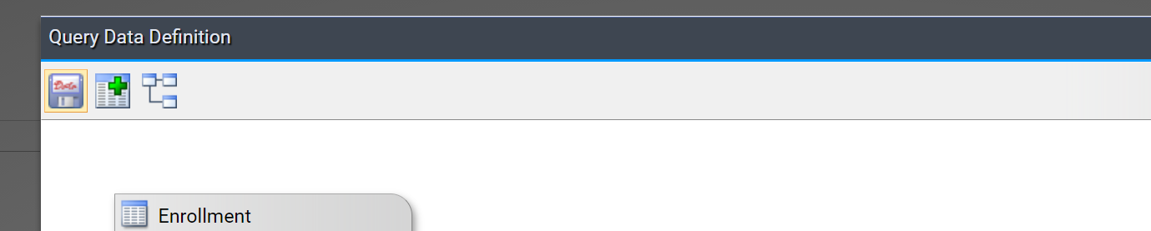
4. Search for the cmComboBoxItem table and click the checkbox to add it to your data definition. Click “Done.”  
   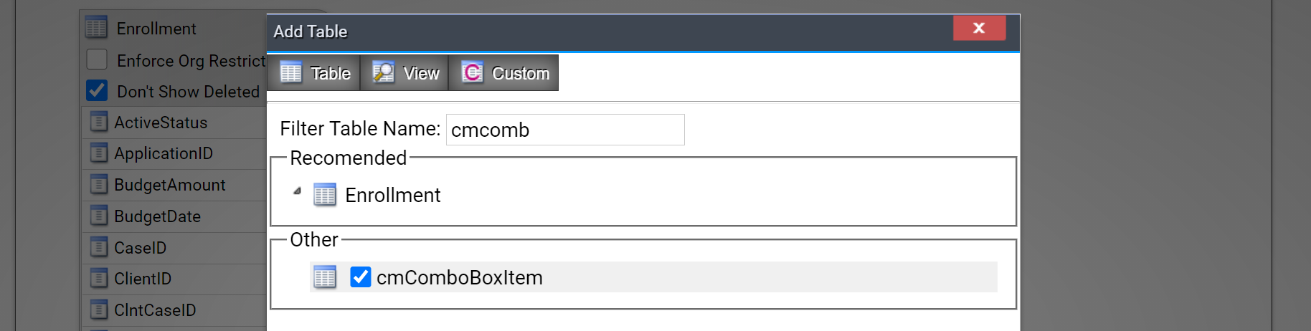
5. (Optional) If you’ll be joining to more than one cmComboBoxItem table, it’s wise to alias each one. Right click on the title of the table, select “Alias,” and enter a clearer table name.  
   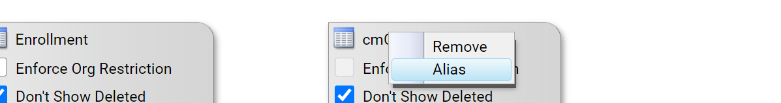
6. Click and drag the item you’re interested in translating from the primary table to the “Item” column in the newly added table to create a relationship.   
   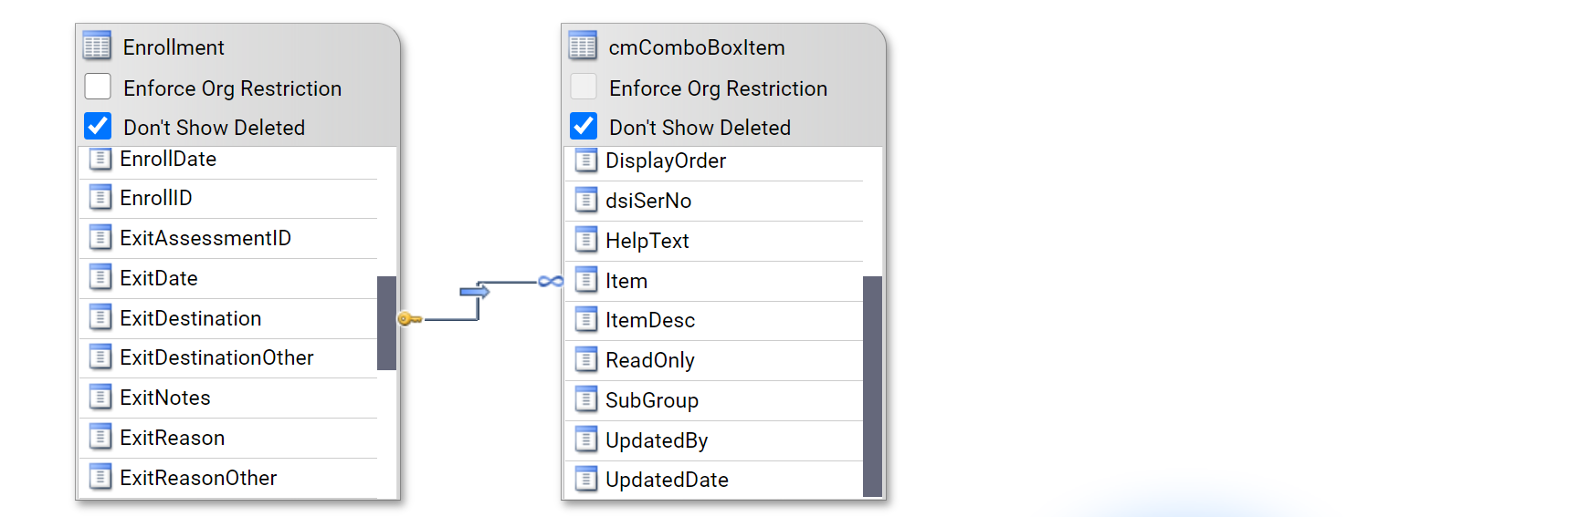
7. Right click the arrow in the new join and select “Advanced Filter.”  
   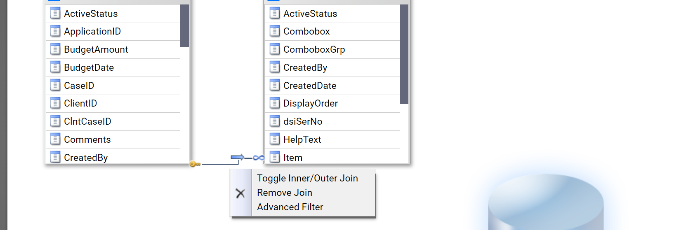
8. Set the Combobox value to the column A value found in step 1 and the ComboboxGrp value to the column B value found in step 2. Click “Done” to save this filter.  
   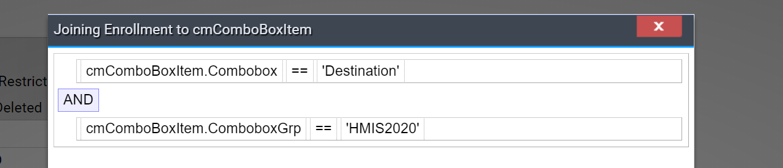
9. Click the save icon in the top left to exit out of the Query Definition window.  
   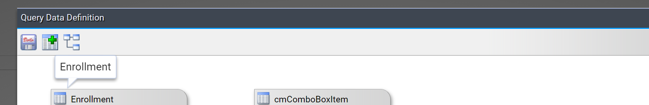
10. Use the cmComboBoxItem “ItemDesc” value to show the text field correctly in your query. This field can have any aggregation applied to it, as appropriate, and should be aliased clearly.  
    